Application Form
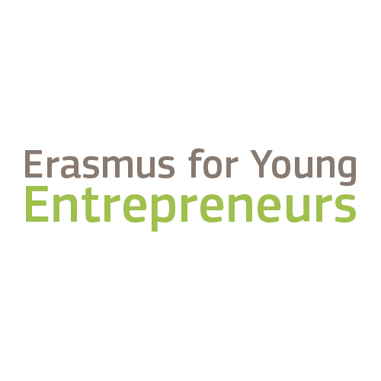
EYE Entrepreneur of the Year Online Awards

EYE Entrepreneur of the Year Online Awards
The EYE Entrepreneur of the Year Online Awards aim to award the most exemplary new entrepreneur (NE) and host entrepreneur (HE) with outstanding stories that demonstrate the effect of the EYE programme on their business activities.

To apply for the award, any new/host entrepreneur, who has taken part in a completed exchange in the EYE programme in the period 01 January 2019 – 31 December 2020 can submit his/her application composed of a 60-seconds video and a short description of the success story. The application form should be sent in electronic format (PDF) to eyeawards@erasmus-entrepreneurs.eu by Friday, 10 September 2021, 18:00 CET the latest.

It will be assessed by a panel with members from the European Commission, EISMEA and the EYE Support Office. The panel will select 5 NE and 5 HE finalists. All finalists will be invited to attend the EYE Entrepreneur of the Year Online Awards event, which will take place during the EYE Network meeting (18-21 October 2021). During this event, the finalists will need to present their story to the audience who will, in turn, vote for the winners.

Note that only finalists will be contacted with further information on their application and participation to the event. The approximate timing for the selection of the finalists identified is 13 September – 30 September 2021.

Eligibility:
- The applicants must have taken part in a completed, successful exchange in the Erasmus for Young Entrepreneurs programme that has started or ended in the period 01 January 2019 – 31 December 2020.
- The applicants must demonstrate the impact of the EYE programme on their business. This means that if the applicant was an aspiring entrepreneur when he/she participated in the EYE, he/she must have now started a business (even if in initial stages).
- The application and the presentation by the finalists must be done in English, therefore the applicants must be fluent in English.
- The applicants must sign the consent form for the use of images/videos/data attached to this application form.

Tips how to do your application:
Consider these points when filming your video and writing about your story:
- Be concise: The video should be max. 60 seconds! Longer contributions will be disqualified.
- Tell your story and make it attractive: Your story should be vivid and engaging. Think what makes your story different from others and make it stand out.
- Demonstrate results: To be the EYE Entrepreneur of the Year, you need to show the impact of the EYE programme on your business and demonstrate the achievements of your business thanks to it.

- Application

General information
Name of the entrepreneur:
Name of the company:
Company website:
Country (and city):
Host or New Entrepreneur? | - Host Entrepreneur  - New Entrepreneur
Contact details (email and telephone):
Intermediary Organisation (the EYE contact point you were registered with):
Relationship number:
Dates of exchange:
Please provide a brief description of your business:
Link to video download file:

You can use the platform https://wetransfer.com/ to create a download link. (You will not need to register on the platform).
Do you agree to be contacted in the future for opportunities to feature your story in publications, audio-visual materials, EYE programme website and social media? | - Yes  - No
Please provide a description of your success story and how the EYE programme had an impact on your entrepreneurial journey.

2000 characters maximum

Specific Privacy statement for the EYE Entrepreneur of the Year Online Awards

Your personal data is processed in accordance with Regulation (EC) No 45/2001on the protection of individuals with regard to the processing of personal data by the Community institutions and bodies and on the free movement of such data.

The data controller of the processing operation is the Head of Unit I.02-SMP/COSME Pillar of the European Innovation Council and SMEs Executive Agency (EISMEA).

The legal basis for the processing operations are Article 5(a) of Regulation EC 45/2001, whereby processing is necessary for the performance of a task carried out in the public interest on the basis of the Treaties or other legal instruments adopted on the basis thereof ; Article 5(d) of Regulation EC 45/2001 based on your consent for the following personal data: film/pictures taken during the event.

The purpose of this processing operation is to:
- Receive your application for the EYE Entrepreneur of the Year Online Awards.
- Assess and verify your application;
- Contact you about the Awards, additional necessary information, as well as promotional opportunities for your story in publications, audio-visual materials, EYE programme website and social media.

The following personal data are collected:
- Name of entrepreneur
- Country and city of residence
- Contact details (email and telephone)

The recipients of your data will be the Erasmus for Young Entrepreneurs Support Office (c/o EUROCHAMBRES), EISMEA and European Commission (DG GROW), who are in charge of the Erasmus for Young Entrepreneurs programme.

Your application will be kept for a maximum period of 12 months after the end of the event, unless you have provided your consent to be contacted in the future for your story to be featured in publications, audio-visual materials, EYE programme website and social media.

You have the right to access your personal data and the right to correct or delete any inaccurate or incomplete personal data. If you have any queries concerning the processing of your personal data, you may address them to the Head of Unit I. 02 –SMP/COSME Pillar of the European Innovation Council and SMEs Executive Agency (EISMEA) (entity acting as data controller) at the following email: EISMEA-COSME-COMMUNICATIONS@ec.europa.eu

You shall have right of recourse at any time to the EISMEA DPO at EISMEA-DPO@ec.europa.eu and to the European Data Protection Supervisor at https://edps.europa.eu.
I hereby acknowledge the above information on the protection of personal data:
- Yes

CONSENT FOR THE USE OF IMAGE/VIDEO or DATA

I, the undersigned:

SURNAME (*):
FIRST NAME (*):
ADDRESS (*):
Phone:
E-MAIL ADRESS:
(*) mandatory information

I hereby acknowledge that on the occasion of the EYE Entrepreneur of the Year Online Awards I will have to provide a short video of myself.

Based on the aforementioned information, I give my explicit consent to be filmed and/or photographed by the organizers and to share with the organizers my videos and pictures. I hereby expressly authorize that my image be so fixed, reproduced, disseminated and / or used, in photographic, filmographic, or multimedia form and by any means whatsoever (known or not yet known), for the communication of the Erasmus for Young Entrepreneurs programme and its Intermediary Organisations.

Such communication may be performed through documents in electronic format, on the website and the social networks of the network of Erasmus for Young Entrepreneurs programme and its Intermediary Organisations for an unlimited duration, and without any geographical restriction as to the frequency of its use.

I also declare that I own all rights related to my images and that the latter are free from any third-party copyright or other intellectual property right. This is subject to my image being used in a manner that does not affect my dignity, my work, nor my private life.

This authorization is given free of charge and only in the context of the establishment's communication as described above.

This agreement binds successors and potential assigns.

Done on at

Signature followed by "read and approved, good for agreement"

Regulation (EC) No 45/2001 of the European Parliament and of the Council of 18 December 2000 on the protection of individuals with regard to the processing of personal data by the Community institutions and bodies and on the free movement of such data (Official Journal of the European Union L 8, 12.01.2001, p. 1.), currently under revision.
EISMEA was set up by Commission Implementing Decision (EU) 2021/173 of 12 February 2021, establishing the European Innovation Council and SMEs Executive Agency (EISMEA) and replacing the Executive Agency for Small and Medium-sized Enterprises (EASME). Pursuant to Article 15 of this Decision, EISMEA has taken over all the legal commitments of EASME and has been subrogated in its rights and obligations.
COSME Regulation: Regulation (EU) No 1287/2013 of 11 December 2013 (Official Journal of the European Union L 347/33 of 20.12.2013).

